Bukalapak Pre-Test Test Engineer Position.

Nursella Zeni Octavina.

Questions and answers :



Arithmetic operation : Integer, Float



Word and character : String

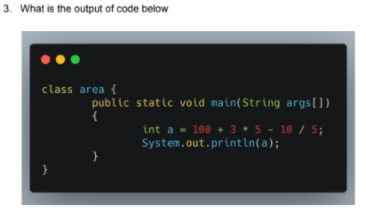

Output : 113

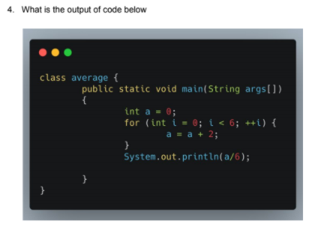

Output : 2

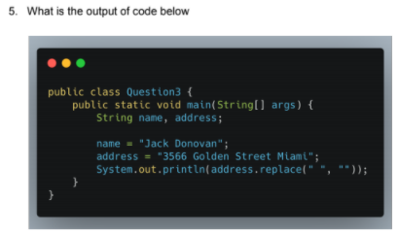

Output : 3566GoldenStreetMiami

**Flaky Test**



Test that yields different results inconsistently in an unreliable behaviour. This test may fail in one moment but suddenly pass when re-running the test.



Captcha is meant to be not accessed automatically, it is used to distinct between human or robot. Good captcha means good security. But there is some way for testing purpose such as creating a test environment that completely disable captcha or work with the developer team for workaround to configure captcha that always accept a specific value.